Beginning Drama : Stage terminology

Name:\_\_\_\_\_\_\_\_\_\_\_\_\_\_\_\_\_\_\_\_\_\_\_\_\_\_\_\_\_

MCEN00359_0000[1] DIFFERENT TYPES OF STAGES and STAGE TERMINOLOGY

Pay special attention to these particular words =High priority words for summative exam. These are words that you will need to know REALLY well for the test.

=Medium priority words. Words that you will need to know pretty well for the summative exam.

=Words that you will need to know for the Formative Quiz coming up

1. GREEN ROOM- Where actors wait to go on stage. At Northglenn this room is 303. What are the two theories behind this name?

a.)

b.)

1. PROSCENIUM- Stage is framed by the proscenium arch, which creates the effect of a \_\_\_\_\_\_\_\_\_\_\_ \_\_\_\_\_\_\_\_\_\_. Is Northglenn High School this kind of stage?\_\_\_\_\_\_\_\_\_\_ **See picture on page 9**
2. THRUST- Stage extensions that extend the stage floor towards the audience. The audience surrounds the stage \_\_\_\_\_\_\_ around. What is this like?\_\_\_\_\_\_\_\_\_\_\_\_\_\_\_\_\_\_\_\_\_\_\_\_\_\_\_\_\_\_\_\_\_\_\_\_\_\_\_\_\_\_\_\_\_\_\_\_\_\_\_\_\_\_\_\_.**See pictures on page** **8 and 10.**
3. ARENA- Performance space totally surrounded by \_\_\_\_\_\_\_\_\_\_\_. **See pictures on page 8 and 11**
4. BLACK BOX – A stage space that allows variable relationships between actors and audience. Found at \_\_\_\_\_\_\_\_\_\_\_\_.
5. RAKE- Stage floor tilted at angle toward the audience. Where we get the terms\_\_\_\_\_\_\_\_\_\_ and\_\_\_\_\_\_\_\_\_ from. [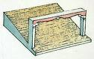](http://images.google.com/imgres?imgurl=http://www.dkimages.com/discover/previews/905/688932.JPG&imgrefurl=http://www.dkimages.com/discover/DKIMAGES/Discover/Home/Performing-Arts/Theatre/Theatres/The-Stage/The-Stage-4.html&usg=__hzLZ_HzvUeQnU7599QDPJuDI74k=&h=266&w=425&sz=36&hl=en&start=3&um=1&tbnid=_iiChUR3CRkw0M:&tbnh=79&tbnw=126&prev=/images?q%3Drake%2Bstage%26hl%3Den%26rls%3Dcom.microsoft:en-us:IE-SearchBox%26sa%3DN%26um%3D1)
6. APRON- Area downstage of act curtain. What is Mrs. Dill’s theory why it is called this?\_\_\_\_\_\_\_\_\_\_\_\_\_\_\_\_\_\_\_\_\_\_\_\_\_\_\_\_\_\_\_\_\_\_\_\_\_\_\_\_\_\_\_\_\_\_\_\_\_\_\_\_\_\_\_\_\_\_\_\_\_\_\_\_\_\_\_\_\_\_\_\_\_\_\_\_\_\_\_\_\_\_\_\_\_\_\_\_\_\_\_\_\_\_\_\_\_\_\_\_\_\_\_\_\_\_\_\_\_\_\_\_\_\_\_\_\_\_\_\_\_\_\_\_\_\_\_\_\_\_\_\_\_\_

**See page 9**

1. HOUSE—Where the audience sits. A person in charge of the ushers is called a house\_\_\_\_\_\_\_\_\_\_\_\_\_\_\_\_\_\_\_\_.

Short ones that mask the lights and pipes

Curtains and backstage terminologY 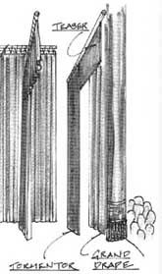

Its blue!

a.

The middle curtain

c.

b.

d.

Tall skinny black ones

1. ACT CURTAIN- The main stage curtain which closes between the acts of a production. What color is Northglenn’s ACT curtain? \_\_\_\_\_\_\_.

This curtain is also called \_\_\_\_\_\_\_\_\_\_\_\_ \_\_\_\_\_\_\_\_\_\_\_\_\_\_\_\_ and the \_\_\_\_\_\_\_\_\_\_\_\_ curtain.

1. TRAVELER- The curtain half way between the act curtain and the upstage wall.

At Northglenn, we call it the \_\_\_\_\_\_\_\_\_\_\_\_\_\_\_\_curtain.

1. TEASERS AND BORDERS – The curtain that mask the lights and batten up above. At Northglenn High School, the teasers are\_\_\_\_\_\_\_\_\_\_\_\_\_\_and the border is\_\_\_\_\_\_\_\_\_\_\_\_\_\_\_\_\_\_\_\_\_\_\_\_\_.
2. TORMENTOR LEGS- The curtains that mask the wings and backstage area. Why are they called legs? \_\_\_\_\_\_\_\_\_\_\_\_\_\_\_\_\_\_\_\_\_\_\_\_\_\_\_\_\_\_\_\_\_\_\_\_\_\_\_\_\_\_\_\_\_\_\_\_\_.

Why do you think they are called tormentors?\_\_\_\_\_\_\_\_\_\_\_\_\_\_\_\_\_\_\_\_\_\_\_\_\_\_\_\_\_\_\_\_\_\_\_\_\_\_\_\_\_\_\_\_\_\_\_\_\_\_\_\_\_\_\_\_\_\_\_\_\_\_\_\_\_\_\_\_\_\_\_\_\_\_\_\_\_\_\_\_\_\_\_\_\_\_\_\_\_\_\_\_\_\_\_\_\_\_\_\_\_\_\_\_\_\_\_\_\_\_\_\_\_\_\_\_\_\_\_\_\_\_\_\_\_\_\_\_

1. SCRIM- a gauze drop that can appear either opaque or transparent depending on the lighting. If lit from behind, it will appear \_\_\_\_\_\_\_\_\_\_\_\_\_\_\_, if lit from in front, it will appear\_\_\_\_\_\_\_\_\_\_\_\_\_\_\_\_\_\_\_\_\_.
2. SKY DROP - Muslin curtain across the back of the stage. Another word for it is? \_\_\_\_\_\_, which is short for\_\_\_\_\_\_\_\_\_\_\_\_\_\_\_\_\_\_\_\_\_\_\_\_\_\_\_\_\_\_\_\_\_.

1. WINGS- Area at the sides of the stage that would be visible to the audience with out curtains. “Waiting in the \_\_\_\_\_\_\_”, is a common theater expression, meaning \_\_\_\_\_\_\_\_\_\_\_\_\_\_\_\_\_\_\_\_\_\_\_\_\_\_\_\_\_\_\_\_\_\_\_\_\_\_\_\_\_\_\_\_\_\_\_\_\_\_\_\_\_\_\_\_\_\_\_\_\_\_\_\_
2. MASK- To \_\_\_\_\_\_\_\_\_\_\_\_ from the audience’s view (such as hiding the wing space with curtains or flats.)
3. BACK STAGE- Areas \_\_\_\_\_\_\_\_\_\_ the audiences view.
4. BATTEN- The \_\_\_\_\_\_\_\_\_ on which lights and curtains are hung. Pipes that allow for the electric hook-up of our theatrical lights are called\_\_\_\_\_\_\_\_\_\_\_\_\_\_\_\_ \_\_\_\_\_\_\_\_\_\_\_\_.
5. TECH- all the support activities behind the actors, including set building& painting, lights, sound, props, costumes, etc. Tech stands for what?\_\_\_\_\_\_\_\_\_\_\_\_\_\_\_\_ \_\_\_\_\_\_\_\_\_\_\_\_\_\_\_\_.

SMALL GROUP TOUR C:\Documents and Settings\dil008540\Local Settings\Temporary Internet Files\Content.IE5\D5BYPXQ4\MCBD07842_0000[1].wmf

1. SHOP- Where most of the construction of set pieces are done. Our shop also houses what? \_\_\_\_\_ \_\_\_\_\_\_\_\_\_\_ \_\_\_\_\_\_\_\_\_\_\_.
2. FLATS - Light weight wooden frames covered with muslin and painted to create walls/background on stage. The treatment of the muslin is called\_\_\_\_\_\_\_\_\_\_\_\_\_and

it is a \_\_\_\_\_\_\_\_\_\_parts glue 1 part \_\_\_\_\_\_\_\_\_\_\_\_\_\_\_\_combination.

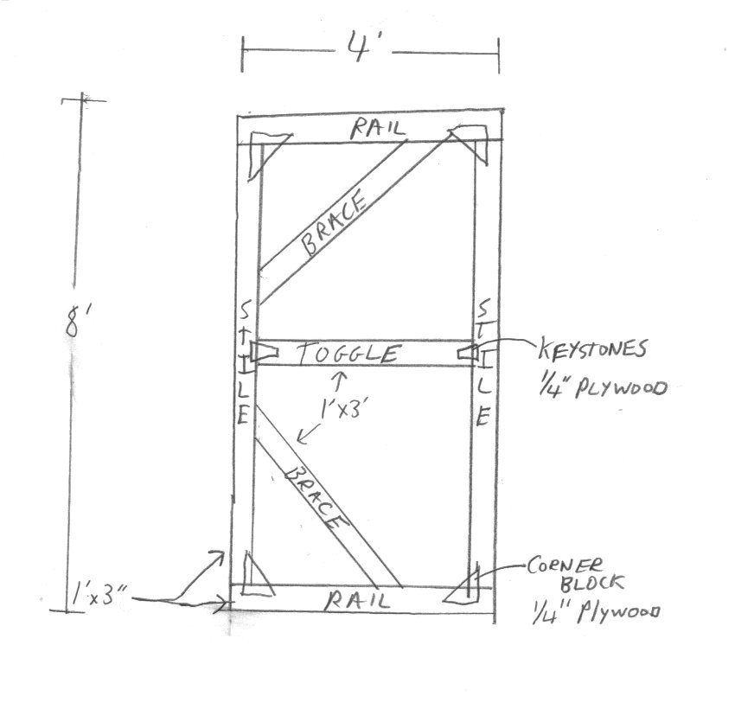

1. PROPS- Three types include:

Props comes from the word\_\_\_\_\_\_\_\_\_\_\_\_\_\_\_\_\_\_\_\_\_\_\_\_\_because props used to be donated by \_\_\_\_\_\_\_\_\_\_\_\_\_ of the theatre in order to get recognition from a theatre company.

|  |  |  |
| --- | --- | --- |
| Category of Prop | Definition of prop | Example of prop/you can draw a picture too. |
|  |  |  |
|  |  |  |
|  |  |  |

1. CAT WALK- The work space for hanging lights above the audience. The purpose of the cat walk is to illuminate the \_\_\_\_\_\_\_\_\_\_\_ of actors faces.
2. LIGHT AND SOUND BOOTH- Housing the light and sound board, both of which are controlled by operators.
   1. One light in the booth is the \_\_\_\_\_\_\_\_\_ light, which moves and allows the operator to \_\_\_\_\_\_\_\_\_\_a performer.

# 

# j0251006ACTING TERMSj0251006

*Skit Expectations:*

You have been assigned one of the above six groups of words to present a creative, active skit with a group of classmates. The expectations of the skit are the following:

1. All members must be involved. It is important to be *heard* and *seen.*
   1. Even if members are absent, please plan for their performance.
   2. If they aren’t here on the performance day, then you can use another class member from another group to cover the performance.
   3. You can write a script (recommended), or use cue cards.
2. All words must be both *said* and *defined* in order to receive full credit.
3. Words need to be *justified* by effective *given circumstances*. In other words, it is important to give reason for why you are saying the words by creating a *time* and *place* of the action that make sense to the words that are given. BE CREATIVE!
4. You will be given class time to work on this; it is imperative that class time is used well and that your skit is planned out with a clear beginning, middle and end. *Improvisation* isn’t recommended for this performance.

**GROUP 1** *Language of the Actor’s text*

|  |  |
| --- | --- |
| AD-LIB | Dialogue or action made up by the actor in a scripted scene or play. |
| IMPROVISATION | A style of acting where the entire dialogue is made-up by the actors. |
| ASIDE | A character’s comments made directly to the audience rather than to the other characters who supposedly do not hear |
| SUBTEXT | The meaning that lies behind the author’s words. It is the actor’s job to interpret and communicate the subtext. |

**GROUP 2:**  *Language of the Actor’s text*

|  |  |
| --- | --- |
| MONOLOGUE | A speech for one actor, found in a play, often times within a dialogue. Often used for auditions. |
| SOLILOQUY | Lines said by a character alone on the stage revealing his thoughts and emotions to the audience. Shakespeare made famous or these types of speeches. |
| DIALOGUE | Conversation between characters |
| BEAT | A pause in text when the actor reflects or changes approaches. |

**GROUP 3:**  *Actor/Director language # 1*

|  |  |
| --- | --- |
| BREAK A LEG | Actor’s version of “good luck” derived from the days when a superior performance was rewarded by being invited to kneel before the king, thus bending a leg. |
| HOLD FOR LAUGHS | Wait until audience laughter begins to diminish before continuing dialogue (the wave effect). |
| PLACES | Warning for actors to assume their positions on stage for the beginning of a scene. |
| PROJECT | Speak louder |

**GROUP 4:**  *Actor/Director language # 2*

|  |  |
| --- | --- |
| BUILD | To increase intensity toward a climactic point. |
| CUE | The last words or action of one actor that prompts the speech or action of another (including curtains and lights.) A popular theatre expression is **pick up your cues**, which means to say your line without leaving a pause between your line and the cue. |
| BUSINESS | Detailed bits of stage action that help to define character (such as setting a table or knitting). |
| COVER | To hide something from an audience (usually a mistake). |

**GROUP 5:**  *Actor/Director language # 3*

|  |  |
| --- | --- |
| GIVEN CIRCUMSTANCES | All the circumstances (time, place, era, past events, relationships, etc.) that affect a character’s actions in the play. |
| MOOD | The atmosphere or emotional content of a scene created by the action, the setting, and the effects. “Doom” for the actor. |
| PACE | The appropriate rate at which a scene should play. |
| FOURTH WALL | Imaginary wall between stage and audience. |

**GROUP 6:**   *Theatre Business Lingo*

|  |  |
| --- | --- |
| CAST | Anyone playing a part in a play. |
| CREW | Those assisting backstage with the technical aspects of a performance |
| DARK | A day off for the actors--a day when the show doesn’t go up. Usually Monday for most professional actors. |
| KILL | To eliminate; for example “Kill the lights” means to turn them off. |

**GROUP 7:**   *Stage Movement Words \*****DILL NEEDS TO SHOW THESE!***

|  |  |
| --- | --- |
| GESTURE | A movement of the body, or part of the body, to express or emphasize ideas, emotions, etc. (nodding, waving the hand) |
| GIVE THE SCENE | Throw focus on the important character or focal point in the scene. |
| SHARE THE SCENE | To assume a position of equal dramatic importance with another actor, usually at one-quarter position. |
| STEAL THE SCENE | To steal audience attention away from the proper focal point. |

**GROUP 8:**   *Acting Analysis Words*

|  |  |
| --- | --- |
| OBJECTIVE | The character’s desire to achieve something; their goal. |
| MOTIVATION | To have a specific reason for saying or doing something. |
| OBSTACLE | Whatever stands in the way of a character’s achieving his/her goal. |
| STAKES | What the character has to lose if he doesn’t achieve his/her objective. A director may ask you to “raise the stakes” if he or she wants you to heighten the intensity of a performance |

**GROUP 9:**   *Acting words that exude a category.*

|  |  |
| --- | --- |
| TIMING | To say lines and or move at the exact, most effective moment. |
| STRIKE | To take down the set and put back any costumes, lights, makeup or props used for a production. This usually occurs after closing night of the performance. |
| TAKE THE SCENE | To capture the audience’s attention legitimately because your character has an important line or entrance. |
| TACTICS | What the character does to achieve what he wants—the specific  actions of the character, expressed by the actor as an active verb. (“to stir-up,” “to avoid,” “to beg.”) |

# MCj02786760000[1]PARTS OF THE STAGE AND BODY POSITIONSMCj02786760000[1]

1. RIGHT STAGE—
2. LEFT STAGE—
3. UP STAGE—
4. DOWN STAGE—
5. ABOVE—Up stage
6. BELOW—Downstage
7. FULL FRONT—
8. FULL BACK—
9. PROFILE RIGHT OR LEFT—
10. ONE QUARTER RIGHT OR LEFT—Actor’s body position facing one quarter away from the audience. If it’s ¼ right, the actor is facing \_\_\_\_, if it is ¼ left, the actor is facing stage left.
11. THREE QUARTER RIGHT OR LEFT— Actor’s body position facing three quarters \_\_\_\_\_\_\_\_\_\_\_\_\_\_\_\_\_\_\_\_\_\_\_\_\_\_\_\_\_\_\_\_\_\_\_\_\_\_\_\_ If it’s ¾ left, the actor is facing away from the audience towards\_\_\_\_\_\_\_\_ \_\_\_\_\_\_\_\_\_\_\_ , if it is ¾ right, the actor is facing away from the audience towards \_\_\_\_\_\_\_\_\_\_ \_\_\_\_\_\_\_\_\_\_\_.
12. BLOCKING—All of an actor’s stage movements and \_\_\_\_\_\_\_\_\_\_\_\_\_\_.
13. CHEAT—To play toward the audience while seeming to converse with others on stage. Another term for this is \_\_\_\_\_\_\_\_\_\_\_ \_\_\_\_\_\_.
14. OPEN-UP—To play a scene toward the audience; to turn the actor’s body more toward the full front position. Two ways to do this are with:
15. Open turns—
16. Upstage arm gestures—
17. CROSS-To \_\_\_\_\_\_\_\_\_\_\_ from one area of the stage to another.
18. COUNTER CROSS—A small movement in the \_\_\_\_\_\_\_\_\_\_\_\_\_\_\_\_ direction from another’s cross in order to remain visible to the audience. The other actor also \_\_\_\_\_\_\_\_\_\_\_\_\_\_ their movements to balance out the movement.

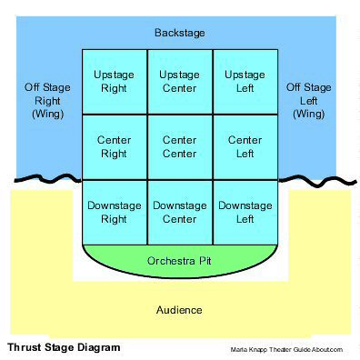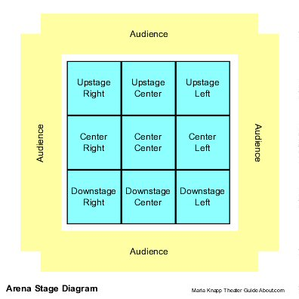

These words should have lightening strikes

|  |  |  |  |
| --- | --- | --- | --- |
| **Act Curtain** | **Ad-lib** | **Arena** | **Aside** |
| **Build** | **Cover** | **Cross** | **Flats** |
| **Gesture** | **Give the Scene** | **Hold for laughs** | **Motivation** |
| **Objective** | **Pick up cues** | **Places** | **Project** |
| **Props** | **Proscenium** | **Steal the Scene** | **Subtext** |

**Key for blanks**

* 1. Actors used to dress in the woods during ancient theatrical events.
  2. Fans would bring plants and flowers to this room and it became kind-or-like a green house.

1. **Blank 1**: Picture Frame/ **Blank 2**: yes
2. **Blank 1**: ¾/**Blank 2**: It is like a model’s runway.
3. Audience
4. Universities
5. **Blank 1**:Upstage **Blank 2**: Downstage
6. Because you can take it off and it is on the front of the stage
7. Manager
   1. Act Curtain
   2. Traveler
   3. Teasers and Borders
   4. Tormentor Legs
8. **Blank 1**: Blue/**Blank 2**: Grand Drape/**Blank 3**:Act
9. Mid
10. **Blank 1:**Black/**Blank 2:**Blue
11. **Blank 1:**Because they are tall and skinny and there are 8 of them, like a spider/ **Blank 2:**Because they are difficult to move
12. **Blank 1:**Translucent or see-through/ **Blank 2:**Opaque or difficult to see-through
13. **Blank 1:**Cyc/ **Blank 2:**Cyclorama
14. **Blank 2:**Wings/ **Blank 2:**to wait before you come onstage.
15. Hide
16. Beyond
17. **Blank 1:**Pipes/ **Blank 2:**Electric battens
18. Technical Theatre
19. Props Loft
20. **Blank 1:**Dutching/ **Blank 2:**3/ **Blank 3:**water
21. Property/Patrons

|  |  |  |
| --- | --- | --- |
| Category of Prop | Definition of Prop | Example of prop/you can draw a picture too |
| Set | Big pieces that stays in one place throughout the scene or play. | Couch |
| Dress | Anything that decorates the stage. | Curtain |
| Hand | Things held by the actors. Also the actors are personally responsible for them. | Apple |

1. Fronts
2. **Blank 1:**Spot/ **Blank 2:**follow

Parts of the Stage and Body Positions:

1. The actors’ right.

2. The actors left.

3. Away from the audience

4. Towards the audience

7 Facing the audience completely.

8. Facing away from the audience completely

9. Facing the right of the stage for profile right, and facing the left side of the sdtage for profile left

10. right

11. **Blank 1:** away from the audience/ **Blank 2:**stage left/ **Blank 3:**stage right

12. positions

13. cheating out

14. Turn towards the audience/Use upstage hands

15. move

16. **Blank 1:** opposite/ **Blank 2:**adjusts.